# Test Document

Relationship between four persons for test:

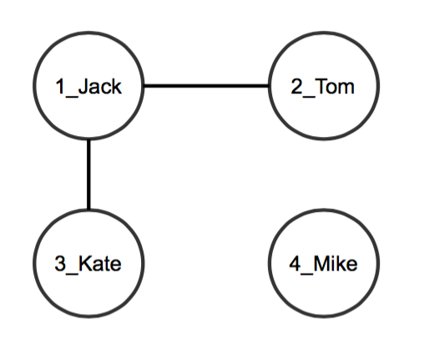

## Part 1: Test Content Posting

*/*sign up*/***INSERT INTO** USERS **VALUES** (1, **'JACK2016'**, **'123456'**, **'http://Techies.com/jack2016/'**);  
**INSERT INTO** USERS **VALUES** (2, **'TOM2016'**, **'123456'**, **'http://Techies.com/tom2016/'**);  
**INSERT INTO** USERS **VALUES** (3, **'Kate2016'**, **'123456'**, **'http://Techies.com/kate2016/'**);  
**INSERT INTO** USERS **VALUES** (4, **'Mike2016'**, **'123456'**, **'http://Techies.com/mike2016/'**);

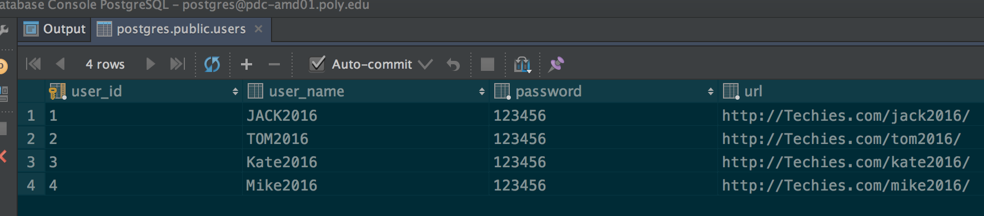

*/*create or edit profiles*/***INSERT INTO** profile **VALUES** (1, **'JACK'**, **'GREEN'**, 18, **'1100'**, **'WEST6'**,  
 **'BROOKLYN'**, **'NY'**, 12345, **'I AM JACK'**, **'DATABASE LEARNER'**, 0, 1);  
  
**UPDATE** profile **SET AGE** = 19 **WHERE profile_id** = 1;  
  
**INSERT INTO** profile **VALUES** (2, **'TOM'**, **'WHITE'**, 20, **'1101'**, **'WEST6'**,  
 **'QUEEN'**, **'NY'**, 12346, **'I AM TOM'**, **'ANDROID LEARNER'**, 0, 2);  
  
**INSERT INTO** profile **VALUES** (3, **'KATE'**, **'BLACK'**, 21, **'1102'**, **'WEST6'**,  
 **'BROOKLYN'**,**'NY'**, 12347, **'I AM KATE'**, **'CLOUD COMPUTING LEARNER'**, 0, 3);  
  
**INSERT INTO** profile **VALUES** (4, **'MIKE'**, **'BLUE'**, 22, **'1103'**, **'WEST6'**,  
 **'BROOKLYN'**,**'NY'**, 12348, **'I AM MIKE'**, **'JAVA LEARNER'**, 0, 4);

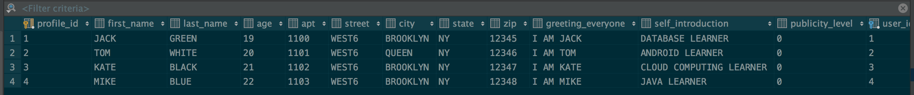

*/*add a new entry to their diaries*/***INSERT INTO** diary **VALUES** (1, **'JACK, NOTE FOR DB'**,  
 **'2016-03-05 11:00:00'**, **'2016-03-05 11:00:00'**, 1, 1);  
  
**INSERT INTO** diary **VALUES** (2, **'TOM, NOTE FOR ANDROID'**,  
 **'2016-03-06 11:00:00'**, **'2016-03-06 11:00:00'**, 1, 2);  
  
**INSERT INTO** diary **VALUES** (3, **'KATE, NOTE FOR CLOUD COMPUTING'**,  
 **'2016-03-07 11:00:00'**, **'2016-03-07 11:00:00'**, 1, 3);  
  
**INSERT INTO** diary **VALUES** (4, **'MIKE, NOTE FOR JAVA'**,  
 **'2016-03-08 11:00:00'**, **'2016-03-08 11:00:00'**, 1, 4);

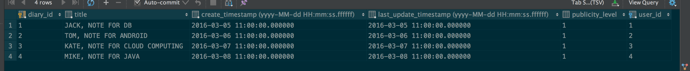

## Part2: Test Friendship

**INSERT INTO** friendship **VALUES** (1, 2, **'2016-03-11 12:00:00'**, **FALSE**, 0);



**UPDATE** FRIENDSHIP **SET successful**=**FALSE  
WHERE request_id** = 1 **AND accept_id** = 2;



**INSERT INTO** friendship **VALUES** (1, 3, **'2016-03-11 12:00:00'**, **FALSE** , 0);  
  
**UPDATE** FRIENDSHIP **SET successful**=**TRUE  
WHERE request_id** = 1 **AND accept_id** = 3;



*/*LIST ALL FRIENDS OF USER WITH ID 1*/*(**SELECT request_id as** user_id  
**FROM** friendship  
**WHERE accept_id**=1)  
**UNION**(**SELECT accept_id as** user_id  
**FROM** friendship  
**WHERE request_id**=1);

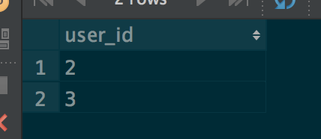

*/*LIST ALL FOF of User with user id 2*/***CREATE VIEW** friend_of_2 **AS**(**SELECT request_id as** user_id  
**FROM** friendship  
**WHERE accept_id**=2)  
**UNION**(**SELECT accept_id as** user_id  
**FROM** friendship  
**WHERE request_id**=2);  
  
(**SELECT request_id as** user_id  
**FROM** friendship  
**WHERE accept_id IN** (**SELECT** user_id **AS** accept_id **FROM** friend_of_2))  
**UNION** (**SELECT accept_id as** user_id  
 **FROM** friendship  
 **WHERE request_id IN** (**SELECT** user_id **AS** request_id **FROM** friend_of_2))  
**EXCEPT** (**SELECT user_id  
 FROM** users  
 **WHERE user_id**=2);

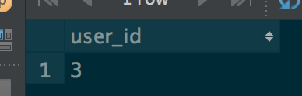

## Part 3: Browse/Search Queries

*/*VIEW FOR ALL FRIENDS*/***CREATE VIEW** friend_of_1 **AS** (  
 **SELECT accept_id as** user_id  
 **FROM** friendship  
 **WHERE request_id**=1  
 **UNION** (**SELECT request_id as** user_id  
 **FROM** friendship  
 **WHERE accept_id**=1)  
);  
  
*/*ALL PROFILES OF FRIENDS*/***SELECT** *\****FROM** profile  
**WHERE publicity_level** < 3 **AND user_id IN** (  
 **SELECT** user_id  
 **FROM** friend_of_1  
 );



*/*ALL DIARIES OF FRIENDS*/***SELECT** *\****FROM** diary  
**WHERE publicity_level** < 3 **AND user_id IN** (  
 **SELECT** user_id  
 **FROM** friend_of_1  
);



*/*VIEW FOR FOF*/***CREATE VIEW** fof_of_2 **AS** (  
 (**SELECT accept_id AS** user_id  
 **FROM** friendship  
 **WHERE request_id IN** (**SELECT user_id FROM** friend_of_2))  
 **UNION** (**SELECT request_id AS** user_id  
 **FROM** friendship  
 **WHERE accept_id IN** (**SELECT user_id FROM** friend_of_2))  
 **EXCEPT** (**SELECT user_id FROM** users **WHERE user_id**=2)  
);

*/*ALL PROFILES OF FOF*/***SELECT** *\****FROM** profile  
**WHERE publicity_level** < 2 **AND user_id IN** (  
 **SELECT** user_id  
 **FROM** fof_of_2  
);



*/*ALL DIARIES OF FOF*/***SELECT** *\****FROM** diary  
**WHERE publicity_level** < 3 **AND user_id IN** (  
 **SELECT** user_id  
 **FROM** fof_of_2  
);



*/*ALL DIARIES WHOSE TITLE CONTAINING SOME KEY WORDS */***CREATE VIEW** diary_id_search_keywords **as** (  
 **SELECT DISTINCT diary_id**, **title  
 FROM** diary  
 **WHERE title LIKE '%DB%' AND** ((**publicity_level** <= 2  
 **AND user_id IN** (**SELECT user_id  
 FROM** friend_of_2)  
 ) **OR** (**publicity_level** <= 1  
 **AND user_id IN** (**SELECT** user_id  
 **FROM** fof_of_2)  
 ) **OR  
 publicity_level** = 0)  
);



*/*a list of all diary entries by his friends during the last week*/* **SELECT diary_id**, **title  
 FROM** diary  
 **WHERE user_id IN** (**SELECT** user_id **FROM** friend_of_1)  
 **AND** (diary.**create_timestamp** > *now*()::**TIMESTAMP** - **INTERVAL '7 day'  
 OR** diary.**last_update_timestamp** > *now*()::**TIMESTAMP** - **INTERVAL '7 day'**);

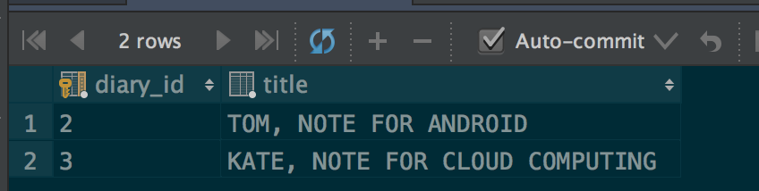

*/*ADD COMMENTS TO OTHER USERS PAGE*/***INSERT INTO** greeting **VALUES**(1, **'Hello TOM! I am JACK'**, 0, 1, 2);  
**INSERT INTO** greeting **VALUES**(2, **'Hello JACK! I am TOM'**, 0, 2, 1);  
**INSERT INTO** greeting **VALUES**(3, **'Hello TOM! I am JACK'**, 0, 2, 4);  
**INSERT INTO** greeting **VALUES**(4, **'Hello JACK! I am TOM'**, 0, 3, 2);

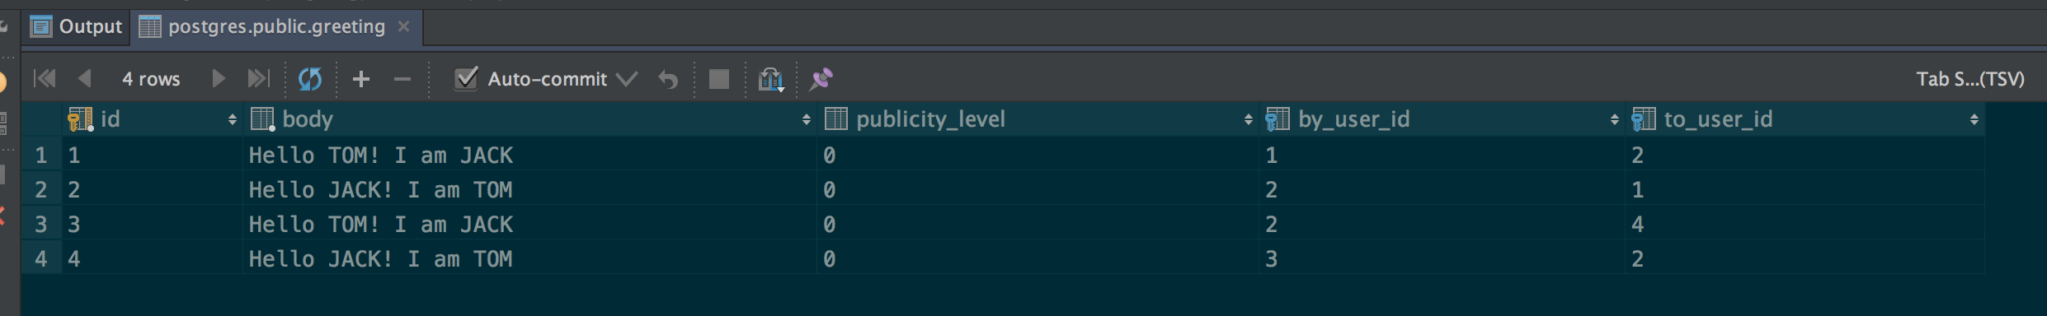

*/*search all greetings posted by her friends anywhere, or by others at her friends’ pages*/***SELECT id**, **body  
FROM** greeting  
**WHERE** (**by_user_id IN** (**SELECT** user_id **FROM** friend_of_1)) **OR** (**to_user_id IN** (**SELECT** user_id **FROM** friend_of_1));

